LaCie 4TB Rugged SSD PRO Thunderbolt 3 External SSD

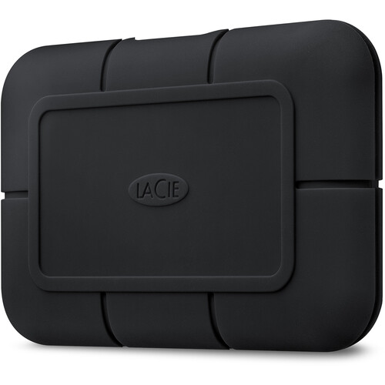

**Key Features:**

* **Capacity**: 4TB of storage, ideal for large files like 4K/6K/8K video, high-resolution images, and extensive project files.
* **Performance**:
  + Blazing-fast speeds of up to **2800 MB/s** for seamless file transfers and video editing directly from the drive.
  + Powered by Seagate FireCuda NVMe SSD technology for uncompromising performance.
* **Connectivity**:
  + **Thunderbolt 3**: Delivers the fastest connection with compatibility for USB-C systems.
  + Compatible with both Mac and Windows devices.

**Warranty and Support:**

* **Limited Warranty**: Comes with a 5-year warranty, ensuring peace of mind.
* **Rescue Data Recovery Services**: Includes a 5-year data recovery plan for unexpected data loss.

**Pricing:**

* Positioned as a premium storage solution for professionals. Prices may vary by retailer.